**Date - 7/12**

**Quantum Computation using Qiskit**

**Chapter 1**

**The Atoms of Computation**

* QuantumCircuit – The function creates quantum circuit with the defined number of qubits. The output bits can also be defined which will be extracted from the circuit at the end.
  + Example:
    - qc = QuantumCircuit(n_q, n_b)
    - n_q = number of qubits
    - n_b = number of bits will be extracted

**Creating an Adder Circuit**

* NOT gate – It flips the bit values. 0 becomes 1 and 1 becomes 0. In qiskit, the NOT gate can be performed by using the ‘x’ operation
  + Example:
    - qc = QuantuamCircuit(n) # creating a circuit with n qubits
    - qc.x(5) # apply NOT gate/x operation on qubit 5

**Adding with Qiskit**

* A circuit is created that encodes the input, perform algorithmic operation and extract outputs.
* XOR gate – The operation refers to the inputs and if both the inputs are same, it will output 0 and if one of the inputs is different, then it will output 1.

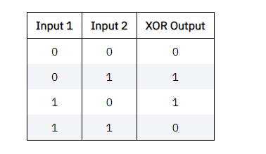

* In Qiskit, the XOR operation can be performed using cx operation.
  + Example:
    - qc = QuantuamCircuit(2) # create a circuit with 2 qubits
    - qc.cx(0,1) # qubit 0 XOR qubit 1
    - Sample screenshot

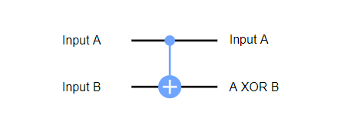

* Toffoli Gate – The operation refers to the control inputs and if both the inputs are in 1 state, then it performed NOT operation on the third input
  + Example:

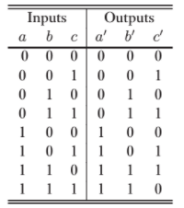

* The toffoli operation can be done using ccx operation in Qiskit
  + Example:
    - qc_ccx = QuantumCircuit(4)
    - qc_ccx.x(0) # apply NOT operation on 0 qubit
    - qc_ccx.x(1) # apply NOT operation 1 qubit
    - qc_ccx.ccx(0,1,3) # apply toffoli operation on 0,1 and 3 qubits